PROJECT 1

Personal Expense Tracker
Objectives:
- Design and implement a personal expense tracker that enables users to manage their expenses
- Allow users to categorize expenses and set monthly budgets
- Implement file-handling functionality to save and load expense data
- Create an interactive, menu-driven interface for ease of use

- 1ST TO DESIGN PERSONAL EXPENSE TRACKER WE HAVE TO DO UTILITIES AND VALIDATION
- WE HAVE TO IMPORT CSV, OS & DATETIME IN THE JUPYTER NOTEBOOK
- FOR DATE VALIDATION
def validate_date(date_str: str) -> bool:
"""Return True if date_str matches YYYY-MM-DD."""
try:
datetime.strptime(date_str, "%Y-%m-%d")
return True
except (ValueError, TypeError):
return False

- TO DEFINE AMOUNT
def safe_parse_amount(amount_str: str):
"""Try to parse a string as float. Return (float, None) or (None, error_msg)."""
try:
amt = float(amount_str)
if amt < 0:
return None, "Amount cannot be negative."
return amt, None
except (ValueError, TypeError):
return None, "Invalid number format."
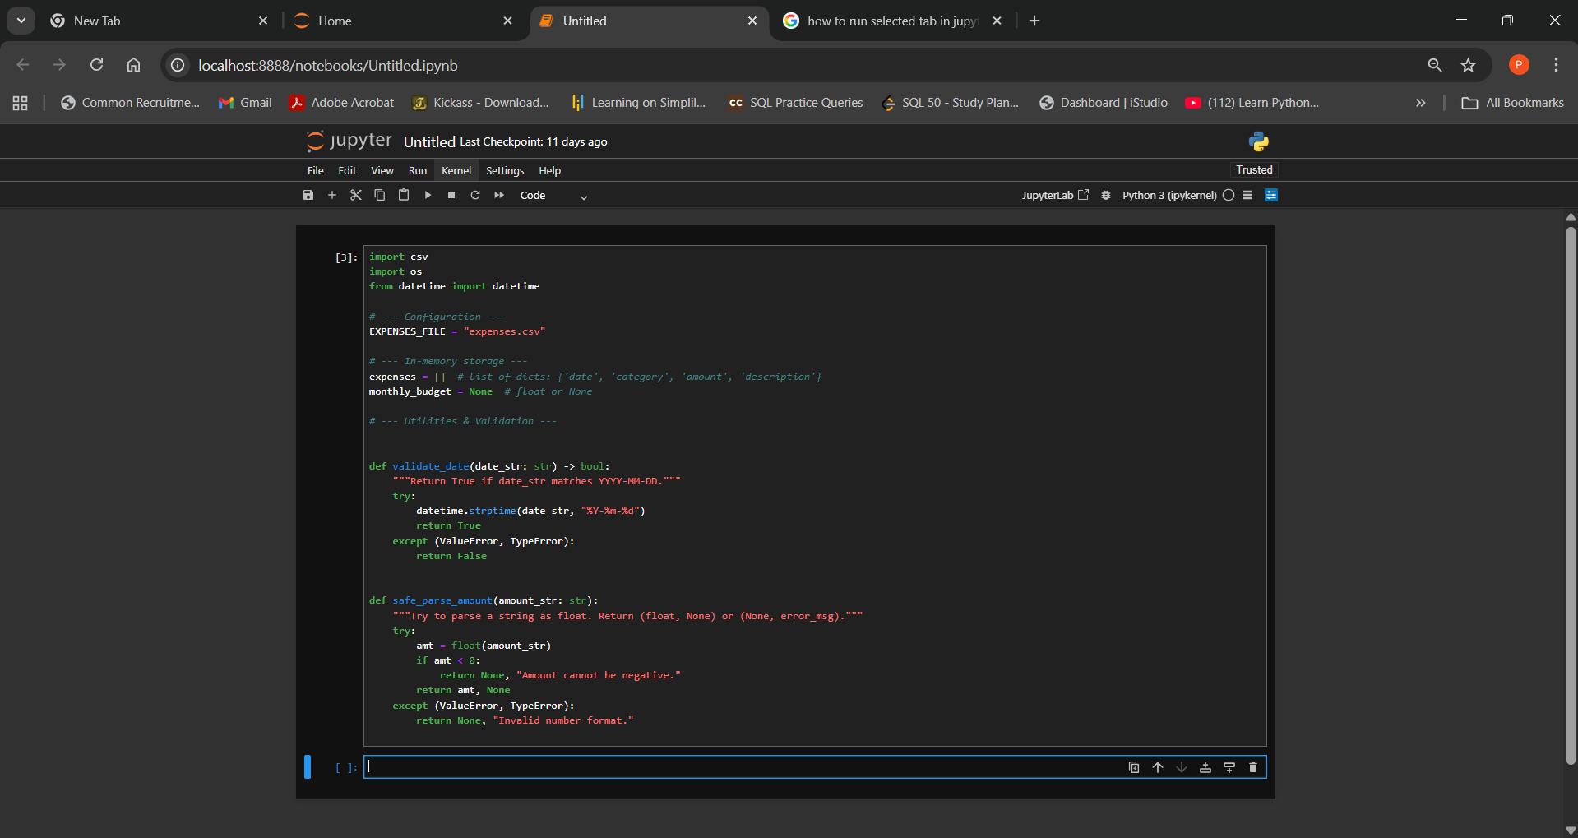

1. Add an expense:
  - Create a function to prompt the user for expense details. Ensure you ask for: The date of the expense in the format YYYY-MM-DD
  - The category of the expense, such as Food or Travel
  - The amount spent
  - A brief description of the expense

• Store the expense in a list as a dictionary, where each dictionary includes the date, category, amount, and description as key-value pairs
Example:
{'date': '2024-09-18', 'category': 'Food', 'amount': 15.50, 'description': 'Lunch with friends'}
def add_expense():
"""Prompt user for expense details, validate them, and append to expenses list."""
print("\nAdd an expense (enter 'q' at any prompt to cancel):")
while True:
date_input = input(" Date (YYYY-MM-DD): ").strip()
if date_input.lower() == 'q':
print("Add expense cancelled.\n")
return
if not validate_date(date_input):
print(" → Invalid date format. Please use YYYY-MM-DD (e.g. 2024-09-18).")
continue
break

while True:
category = input(" Category (e.g. Food, Travel): ").strip()
if category.lower() == 'q':
print("Add expense cancelled.\n")
return
if not category:
print(" → Category cannot be empty.")
continue
break

while True:
amount_input = input(" Amount (e.g. 15.50): ").strip()
if amount_input.lower() == 'q':
print("Add expense cancelled.\n")
return
amount, err = safe_parse_amount(amount_input)
if err:
print(f" → {err}")
continue
break

while True:
description = input(" Description (brief): ").strip()
if description.lower() == 'q':
print("Add expense cancelled.\n")
return
if not description:
print(" → Description cannot be empty.")
continue
break

entry = {
"date": date_input,
"category": category,
"amount": float(amount),
"description": description,
}
expenses.append(entry)
print("Expense added successfully:\n ", entry, "\n")

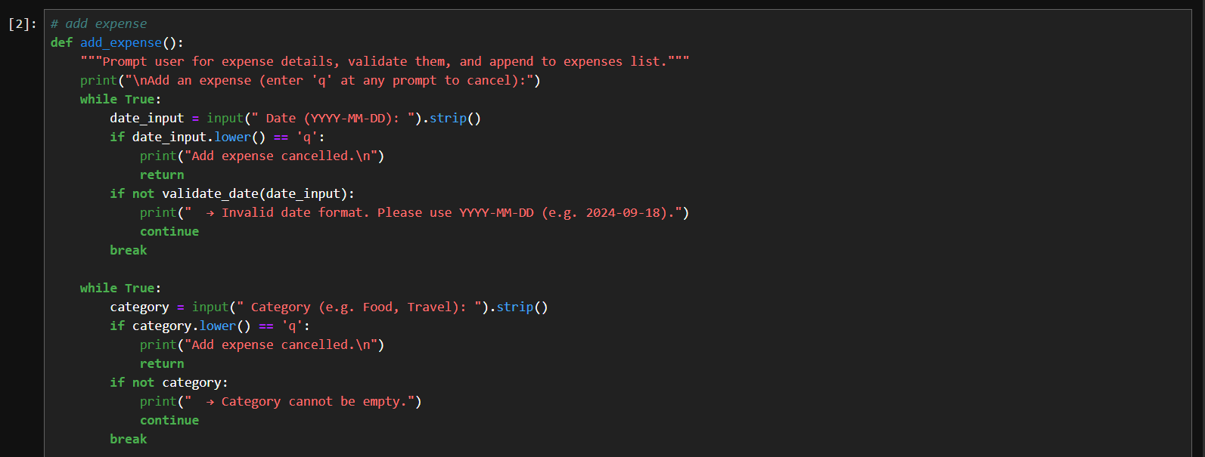
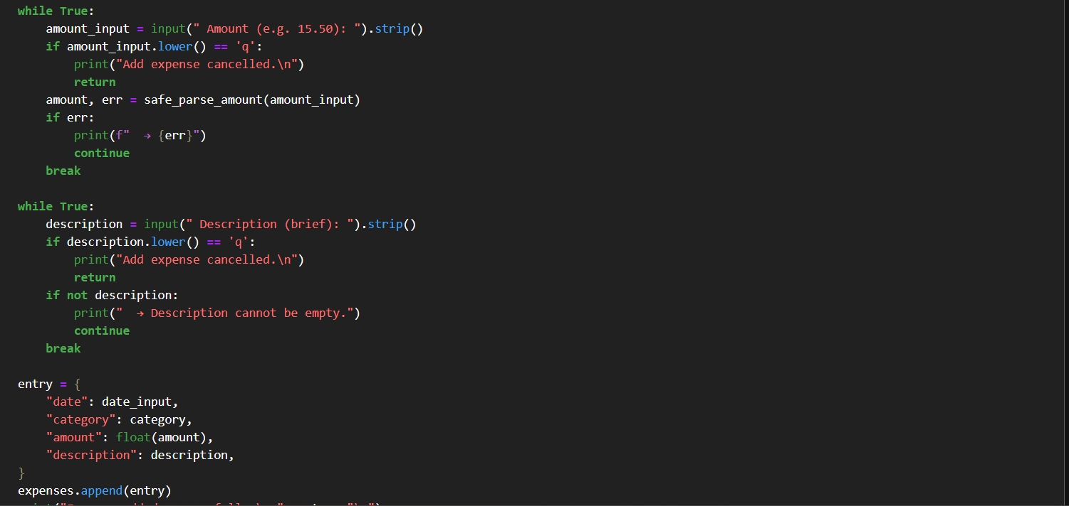

2. View expenses:
  - Write a function to retrieve and display all stored expenses Ensure the function loops through the list of expenses and displays the date, category, amount, and description for each entry

  - Validate the data before displaying it If any required details (date, category, amount, or description) are missing, skip the entry or notify the user that it’s incomplete

def view_expenses():
"""Display all valid stored expenses. Skip or notify if incomplete entries found."""
if not expenses:
print("\nNo expenses recorded yet.\n")
return

print("\nStored expenses:")
total = 0.0
valid_count = 0
skipped_count = 0

for idx, e in enumerate(expenses, start=1):
# Validate required fields
date = e.get("date")
category = e.get("category")
amount = e.get("amount")
description = e.get("description")

malformed = False
reasons = []
if not date or not validate_date(date):
malformed = True
reasons.append("invalid/missing date")
if not category:
malformed = True
reasons.append("missing category")
try:
amt = float(amount)
if amt < 0:
malformed = True
reasons.append("negative amount")
except Exception:
malformed = True
reasons.append("invalid/missing amount")
if not description:
malformed = True
reasons.append("missing description")

if malformed:
skipped_count += 1
print(f" {idx}. [SKIPPED] Incomplete entry: {e} → {', '.join(reasons)}")
continue

# Print formatted valid entry
print(f" {idx}. {date} | {category} | {amount:.2f} | {description}")
total += float(amount)
valid_count += 1

print(f"\nSummary: {valid_count} valid entries, {skipped_count} skipped. Total = {total:.2f}\n")
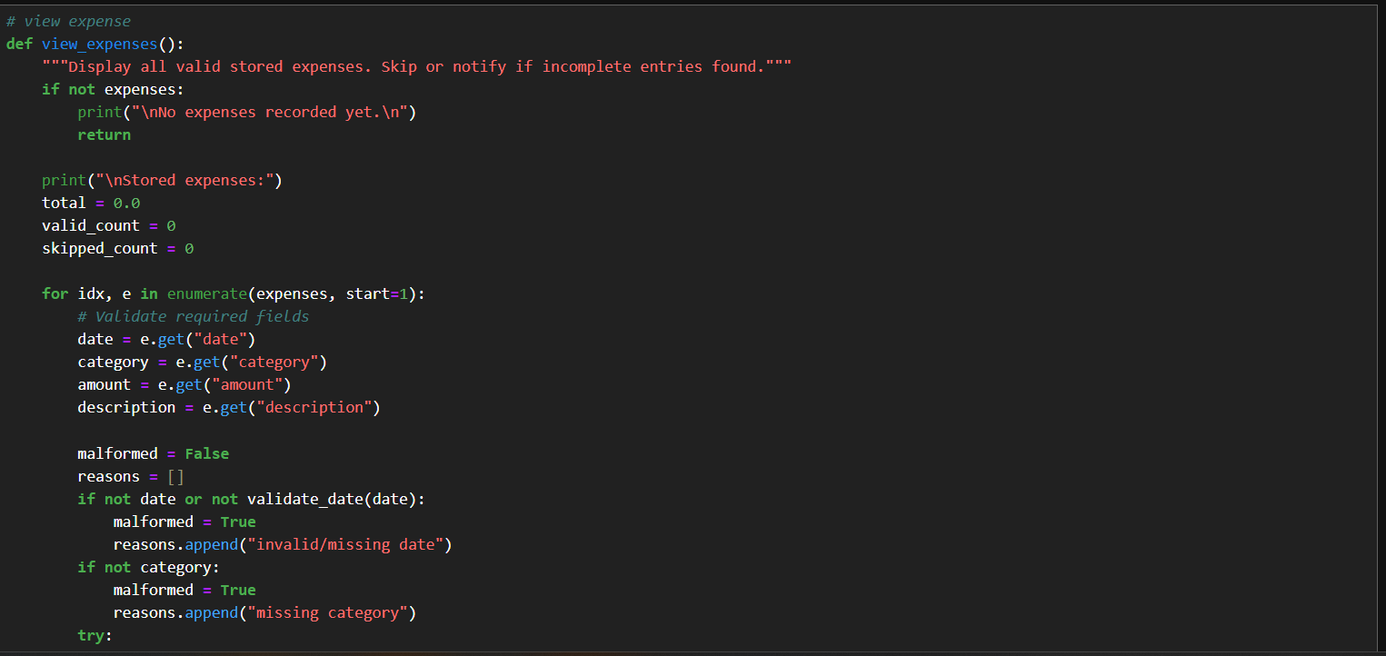
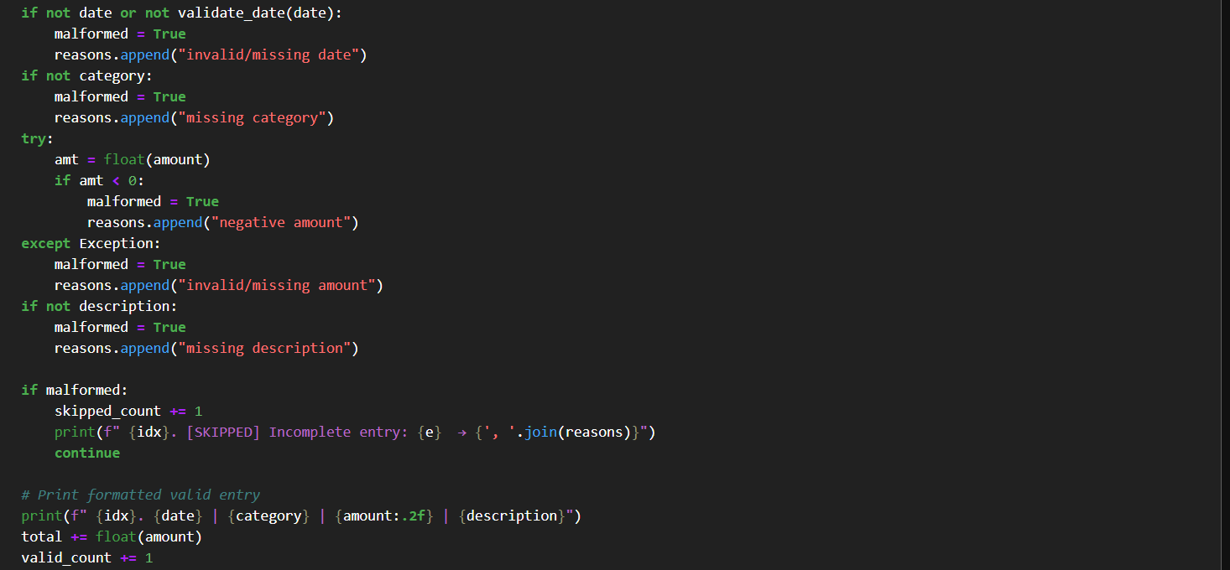

3. Set and track the budget:
• Create a function that allows the user to input a monthly budget. Prompt the user to:
o Enter the total amount they want to budget for the month
• Create another function that calculates the total expenses recorded so far
o Compare the total with the user’s monthly budget
o If the total expenses exceed the budget, display a warning (Example: You have exceeded your budget!)
o If the expenses are within the budget, display the remaining balance (Example: You have 150 left for the month)
# calculate total expense
def calculate_total_expenses() -> float:
"""Return the sum of valid expense amounts."""
total = 0.0
for e in expenses:
try:
amt = float(e.get("amount", 0))
if amt >= 0:
total += amt
except Exception:
# skip malformed amounts
pass
return total
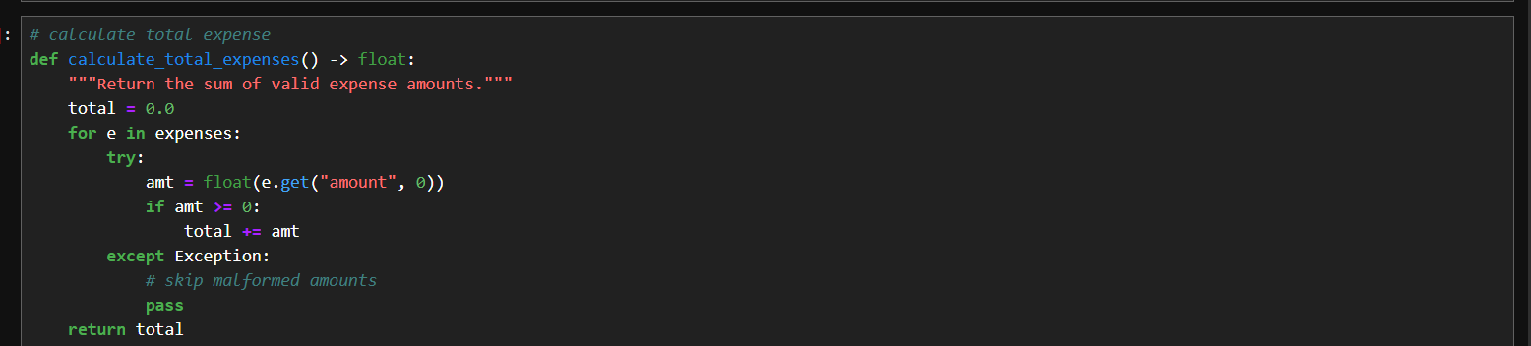

#set monthaly budget
def set_monthly_budget():
"""Prompt the user to enter the monthly budget and store it."""
global monthly_budget
while True:
b = input("Enter your monthly budget amount (e.g. 1000.00): ").strip()
amt, err = safe_parse_amount(b)
if err:
print(f" → {err}")
continue
monthly_budget = amt
print(f"Monthly budget set to: {monthly_budget:.2f}\n")
return

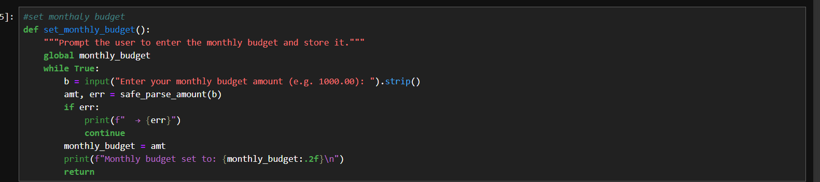

# track budget
def track_budget():
"""
Compare total expenses with user's monthly budget.
- If budget not set, prompt to set one.
- Show remaining balance or a warning if exceeded.
"""
global monthly_budget
if monthly_budget is None:
print("\nNo monthly budget set yet.")
set_now = input("Would you like to set it now? (y/n): ").strip().lower()
if set_now == 'y':
set_monthly_budget()
else:
print("Budget tracking cancelled.\n")
return

total = calculate_total_expenses()
print(f"\nTotal expenses so far: {total:.2f}")
print(f"Monthly budget: {monthly_budget:.2f}")

if total > monthly_budget:
diff = total - monthly_budget
print(f" You have exceeded your budget by {diff:.2f}!")
elif total == monthly_budget:
print("You have used your full budget for the month.")
else:
remaining = monthly_budget - total
print(f"You have {remaining:.2f} left for the month.")
print("")

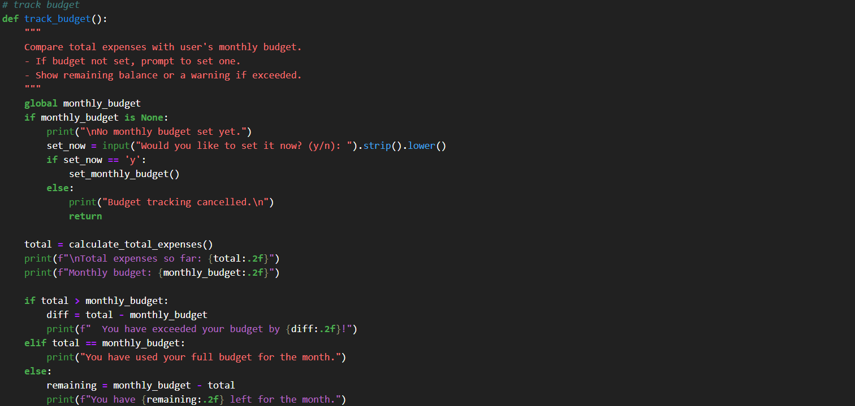
4. Save and load expenses:
• Implement a function to save all expenses to a CSV file, with each row containing the date, category, amount, and description of each expense
• Create another function to load expenses from the CSV file. When the program starts, it should:
o Read the saved data from the file
o Load it back into the list of expenses so the user can see their previous expenses and continue from where they left off
# save and load csv
def save_expenses_to_csv(filename: str = EXPENSES_FILE):
"""Save all expenses to a CSV file (date, category, amount, description)."""
try:
with open(filename, mode="w", newline="", encoding="utf-8") as f:
fieldnames = ["date", "category", "amount", "description"]
writer = csv.DictWriter(f, fieldnames=fieldnames)
writer.writeheader()
for e in expenses:
# Ensure we write safe values
row = {
"date": e.get("date", ""),
"category": e.get("category", ""),
"amount": f"{float(e.get('amount', 0)):.2f}" if e.get("amount") is not None else "",
"description": e.get("description", ""),
}
writer.writerow(row)
print(f"Expenses saved to '{filename}'.\n")
except Exception as exc:
print(f"Error saving expenses: {exc}\n")
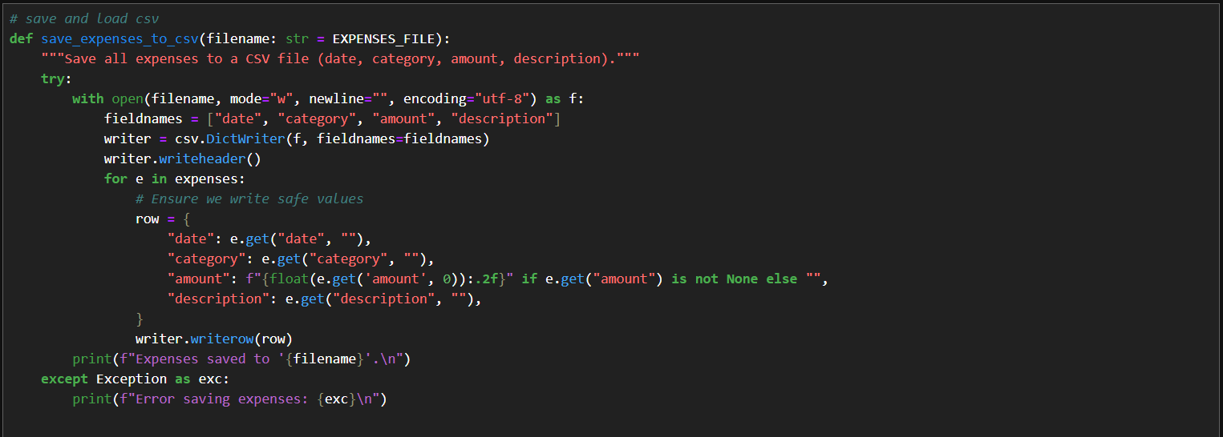
#LOAD CSV
def load_expenses_from_csv(filename: str = EXPENSES_FILE):
"""Load expenses from a CSV file into the in-memory list (validate each row)."""
if not os.path.exists(filename):
# No file to load
return

loaded = 0
skipped = 0
try:
with open(filename, mode="r", newline="", encoding="utf-8") as f:
reader = csv.DictReader(f)
for row in reader:
date = (row.get("date") or "").strip()
cat = (row.get("category") or "").strip()
amt_str = (row.get("amount") or "").strip()
desc = (row.get("description") or "").strip()

# Basic validation
if not date or not validate_date(date):
skipped += 1
continue
amt, err = safe_parse_amount(amt_str)
if err:
skipped += 1
continue
if not cat or not desc:
skipped += 1
continue

expenses.append({
"date": date,
"category": cat,
"amount": float(amt),
"description": desc,
})
loaded += 1

print(f"Loaded {loaded} expenses from '{filename}'. Skipped {skipped} malformed rows.\n")
except Exception as exc:
print(f"Error loading expenses from '{filename}': {exc}\n")
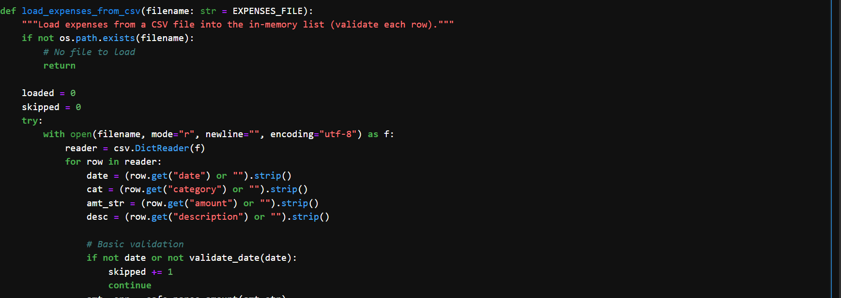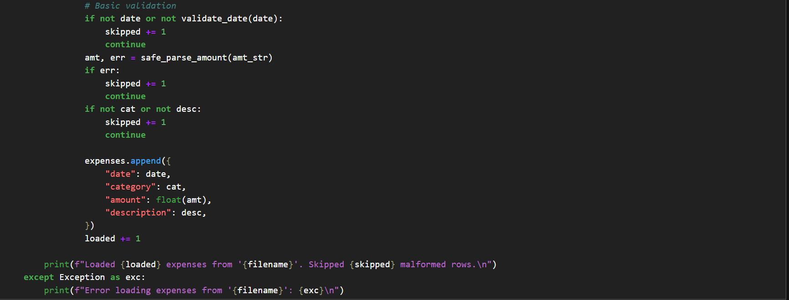

5. Create an interactive menu:
• Build a function to display a menu with the following options:
o Add expense
o View expenses
o Track budget
o Save expenses
o Exit
• Allow the user to enter a number to choose an option
• Implement the following conditions:
o If the user selects option 1, call the function to add an expense
o If the user selects option 2, call the function to view expenses
o If the user selects option 3, call the function to track the budget
o If the user selects option 4, call the function to save expenses to the file
o If the user selects option 5, save the expenses and exit the program
# menu & main loop
def print_menu():
print("Expense Tracker Menu:")
print(" 1) Add expense")
print(" 2) View expenses")
print(" 3) Track budget")
print(" 4) Save expenses")
print(" 5) Exit (saves and quits)")
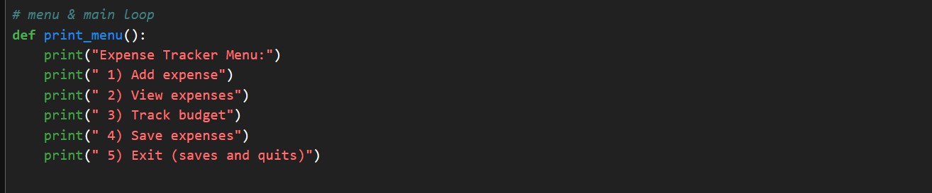
def main():
load_expenses_from_csv(EXPENSES_FILE)
try:
while True:
print_menu()
choice = input("Choose an option (1-5): ").strip()
if choice == "1":
add_expense()
elif choice == "2":
view_expenses()
elif choice == "3":
# Ask user if they want to just view comparison or set budget first
track_budget()
elif choice == "4":
save_expenses_to_csv(EXPENSES_FILE)
elif choice == "5":
save_expenses_to_csv(EXPENSES_FILE)
print("Goodbye! Expenses saved. Exiting.")
break
else:
print("Invalid option. Please choose a number between 1 and 5.\n")
except KeyboardInterrupt:
print("\nDetected keyboard interrupt. Saving expenses before exit...")
save_expenses_to_csv(EXPENSES_FILE)
print("Exited via keyboard interrupt. Goodbye.")

if __name__ == "__main__":
main()
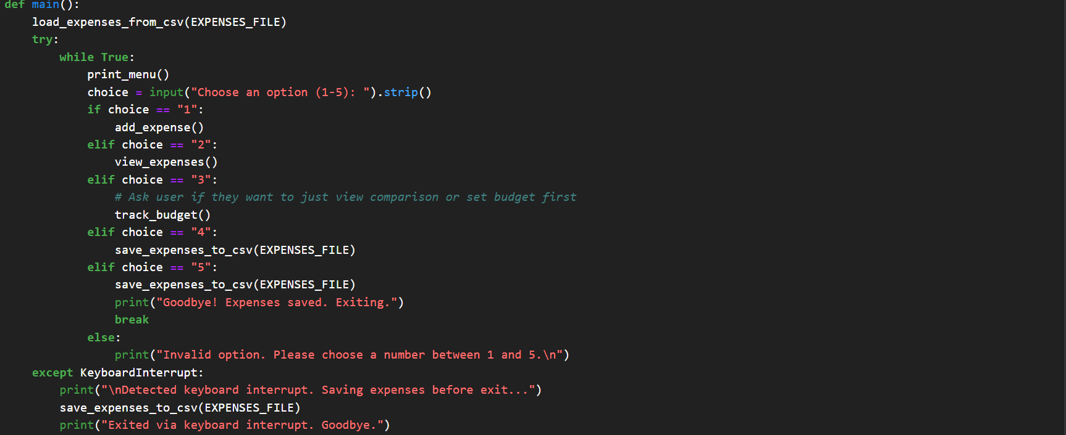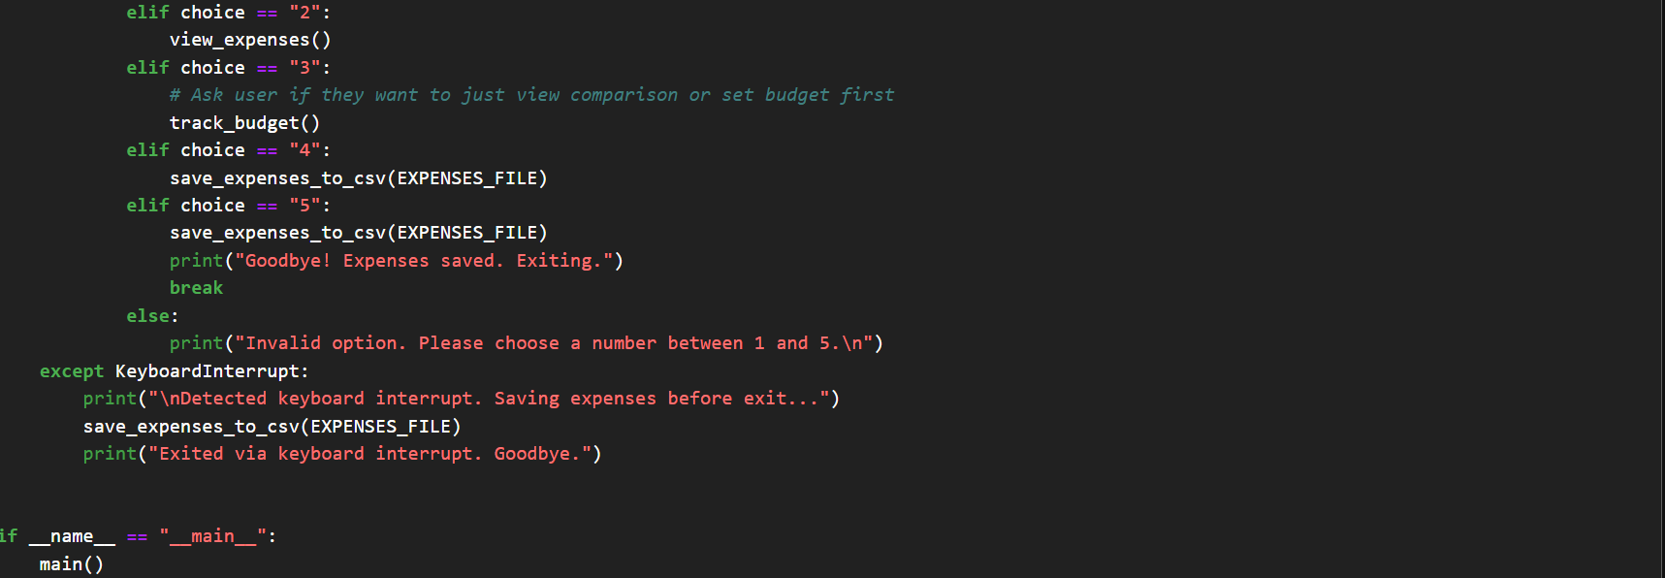

#OUTPUT
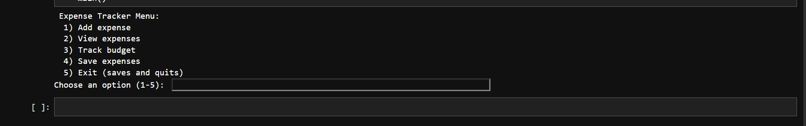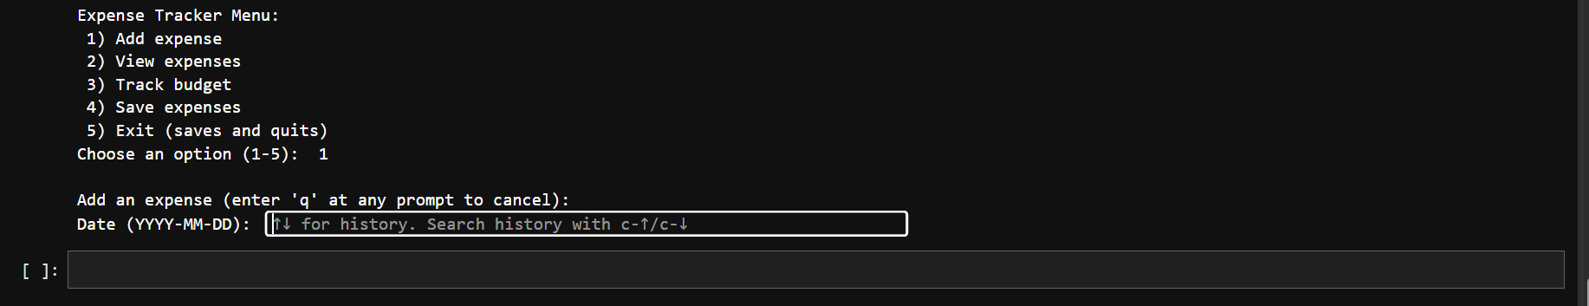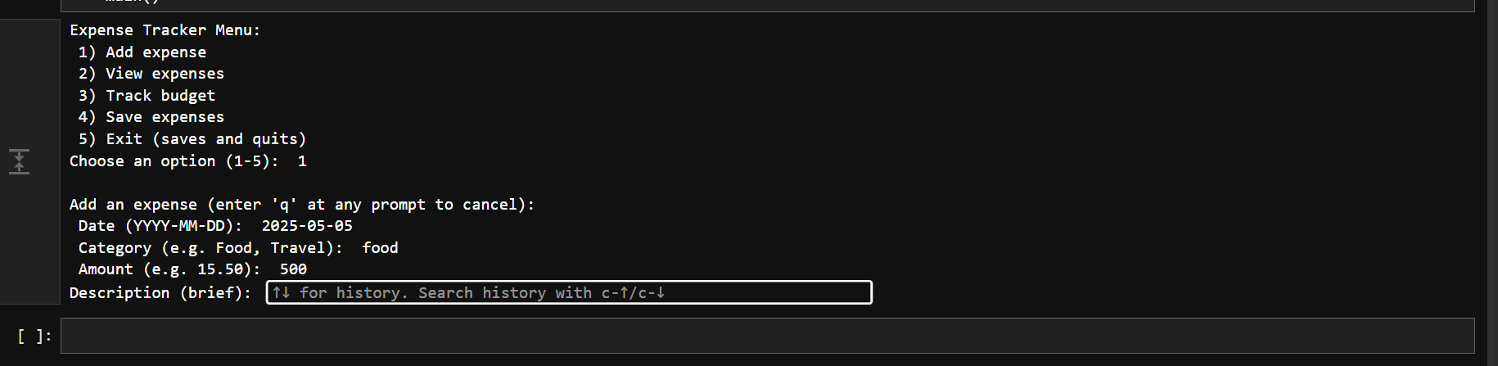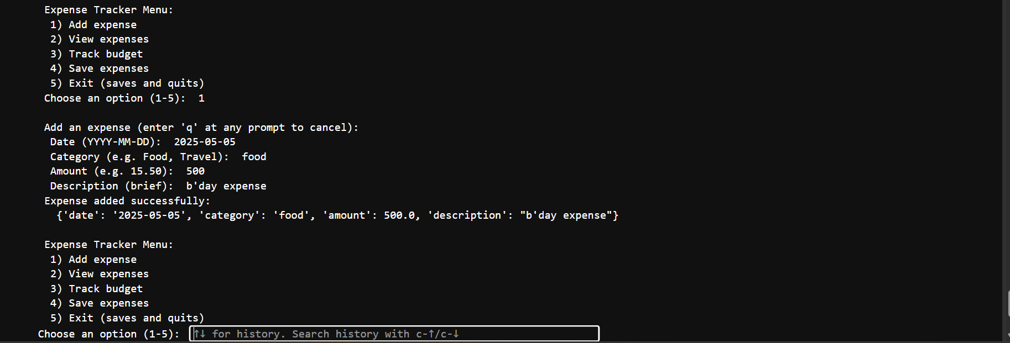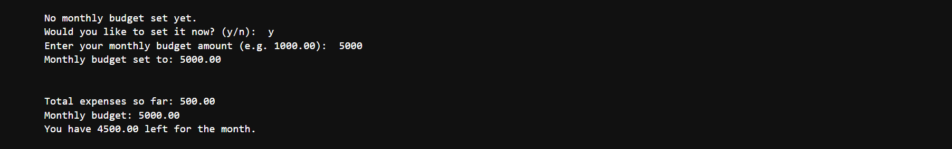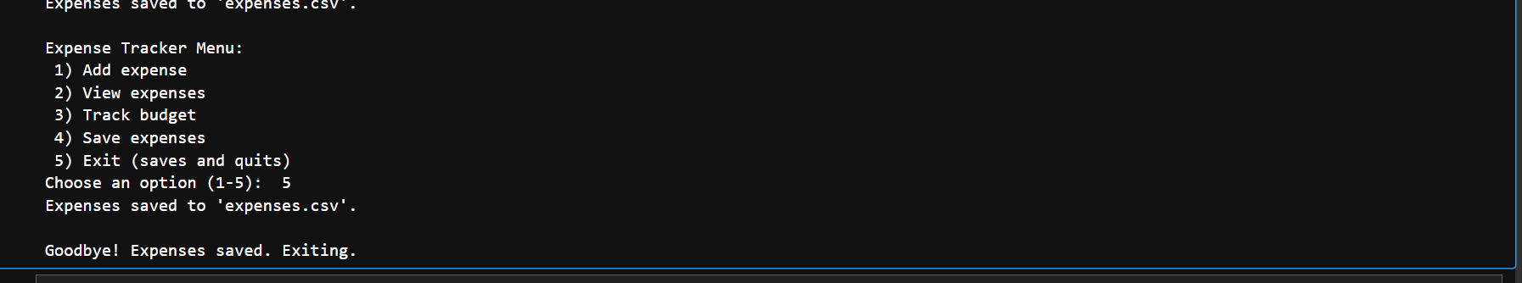
http://localhost:8889/notebooks/simple%20expense%20tracker.ipynb

